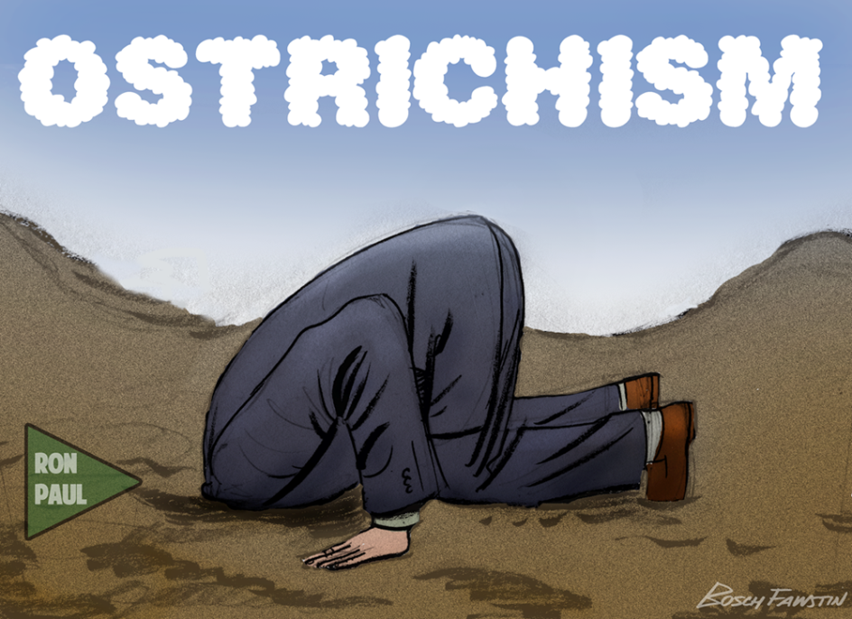
Risk
Acceptance
Ostrichism - Self-delusion, a refusal to cope with something, such as a threat—figuratively hiding one's head in the sand, as the animal is mistakenly thought to do
Metaphorical term; “Ostrichism.” The Oxford English Dictionary defines it as, “The policy of hiding the head like an ostrich.” It can be defined as “A policy of burying one’s head in the sand, i.e. ignoring the reality of a situation,” which explains the meaning of the metaphor. So, perhaps we can sum up a policy of Safety Ostrichism as: “Believing one is safe in the face of a potential threat, even though all one has done is chosen to ignore certain realities of the situation giving rise to that threat.”

“We have never been hurt doing it this way the last 10 years.” “It’s her right to choose not to wear that ill-fitting, uncomfortable PPE.” Hey, I wouldn’t work live but he knows the danger too.” “Sure he could get hurt but it’s not my job to correct him.”
If we confront comments like those above, how should we respond? We can ignore them and keep walking but what if this time the person does get hurt? Will we feel guilty for not speaking up? The legendary, safety motivational speaker, my friend, John Drebinger, https://www.drebinger.com/ says if the answer to that last question is yes, then we must speak up. If we are truly “Watching out for each other’s safety” then we have an obligation to point out the oversite, cognitive breakdown or effect of distraction.
Hazards will not go away simply because we choose to ignore or discount them. Our complacency may lead us to perform at-risk behaviors. Our potentially dangerous activity increases the risk that TODAY our good luck may run out and the unexpected and avoidable adverse outcome will become our reality!
So how do we avoid catching the infections attitude of Ostrichism? I ask you to consider the following: Be active in searching for hazards, go out and watch your crews at work, conduct risk assessments and job safety observations; conduct pre-job briefings and de-briefings after the task is completed. Role model the activities you desire and motivate people by displaying the attitudes you want to instill. I think one of the best interventions I have encountered is to post and present Don Merrill’s great poem; I Chose To Look the Other Way. (Right click on the links to open.)

